**Project Information**

**\*\*Strictly follow case/naming conventions mentioned in this document.**

* Homepage-Customized HTML5 (Video on homepage)
* SignUp-Wizard
* Update Account information-Dataform
* SignIn-TextBox
* For price calculation: NumericTextBox
* For Image hover information: ToolTip
* If person puts something on bid or someone bids more amount: Notification

1. **Database name**: it485nnrs
2. **Tables/UI/Modules**:
   1. Nivedita

|  |
| --- |
| **signintable** |
| email(PK):varchar(50)  password:varchar(50) |

email-PK –email address validation for format and uniqueness (from DB through AJAX)

password- The password has to be at least 6 characters long. (Custome JS available)

For login form [this](http://demos.telerik.com/aspnet-ajax/textbox/overview/defaultcs.aspx) should be the UI. (Comment box not needed)

On UI Log in button should be present.

Forget password link should be present for now.(will write code for it later)

If user enters wrong credential 3 times, a [Captcha](http://demos.telerik.com/aspnet-ajax/captcha/examples/overview/defaultcs.aspx) should appear asking the user. Prove you are Human and after all the correct information user should be proceeded. For now, redirect the user to some blank memberHome.aspx page.

* 1. Nikunj

|  |
| --- |
| **signuptable** |
| firstname:varchar(50)  lastname:varchar(50)  address:varchar(200)  city :varchar(50)  country: varchar(50)  state:varchar(50)  zip:varchar(10)  homePhone:varchar(50)  cellPhone:varchar(50)  email(FK) :varchar(50)  password: varchar(50)  imagePath: varchar(200)  enableTextMsg: varchar(50)  subscribeEmail: varchar(50)  permission: varchar(50) NOT null |

* We need to use [wizard](http://demos.telerik.com/aspnet-ajax/wizard/overview/defaultcs.aspx) for registration form. (Will break the form into logical views)
* Country and State will be pre-populated from the web service (Nikunj will code that).
* Zip validation is required (through **Ajax** or AutoEventWireup-onChange event-refer assignment).
* UI should ask user if he wants to receive text messages? Radio Y/N
* ~~On front-end create~~ [~~captcha~~](http://demos.telerik.com/aspnet-ajax/captcha/examples/overview/defaultcs.aspx) ~~before submit button.~~ After submit, information must reach in both signintable and signuptable. After successful sign-up an email, text message (if Y –fetch cellphone from DB for this purpose) and confirmation page (for now redirect to blank SignUpSuccess.aspx page).
* On front-end create radio which asks user if he wants to subscribe for email updates? (This may be used later on to remove user from subscription list)
* User should also have an ability to upload his image while creating the profile.
* Add 4 level of permission- Public, Designer/Donor, Steering Committee, and Admin. Make changes in UI (not NULL-front-end validation) and Database.
* List of countries.
* Ajax at email.
  1. Shubhanjli

**Update user profile**: Create a standalone app which ask user to enter email address (store this email at session level variable) and then retrieve the data from signuptable table and prepopulate the [dataform](http://demos.telerik.com/aspnet-ajax/dataform/overview/defaultcs.aspx). If user clicks on edit button all the fields (except email address) should become editable. If user clicks update button all the information should get updated and saved in the database.

(Refer the hyperlinked dataform – we don’t need to have delete, insert and cancel button. Also, right/left navigation button shown in the bottom of page are not required.) Here also, we have to take care about the user input validations (which are done during the registration- Nikunj will create a custom validator JS file which can be used here as well.)

We need to keep the custom JS intact (don’t make changes in that).

* Add 4 level of permission- Public, Designer/Donor, Steering Committee, and Admin. Make changes in UI-Read-only field coming from database.
  1. Rajneesh

**Login for anonymous bidders**: Point-1 mentioned [here](https://sites.google.com/site/it353isu/home/project/project-fall15/q-a).

|  |
| --- |
| **anonymousbiddertable** |
| firstname: varchar(50)  lastname: varchar(50)  cellPhone: varchar(50) |

Create a standalone app which asks user to enter name and cellphone in [this](http://demos.telerik.com/aspnet-ajax/textbox/overview/defaultcs.aspx) way (No need for comment section). ~~Additionally have a~~ [~~captcha~~](http://demos.telerik.com/aspnet-ajax/captcha/examples/overview/defaultcs.aspx) ~~before allowing user to submit.~~ Once user enters everything save the details in **anonymousbiddertable** table and save name and phone number at the session level and direct the user to some empty page (for now) bidOnline.aspx

* Need more clarification. Where do we need to direct anonymous user?

**\*\*\*\*\*\*\*\*\*\*\*First Integration on Sunday 18 Oct 2015.\*\*\*\*\*\*\*\*\*\*\*\*\*\*\*\*\*\***

**Part-2**

1. Enter Auction Item(later in 3rd meeting display items image-in UI-display times until the end date of bidding)-***Nikunj***

|  |
| --- |
| auctionitemstable |
| itemType: varchar(5)  itemNumber: Int Identity (Auto increment)  category: varchar(50)  itemDesc: varchar(200)  designer: varchar(50)  estimatedValue: varchar(50)  minBid: varchar(50)  angelPrice: varchar(50)  itemImagePath varchar(200)  PK on (itemType, itemNumber) |

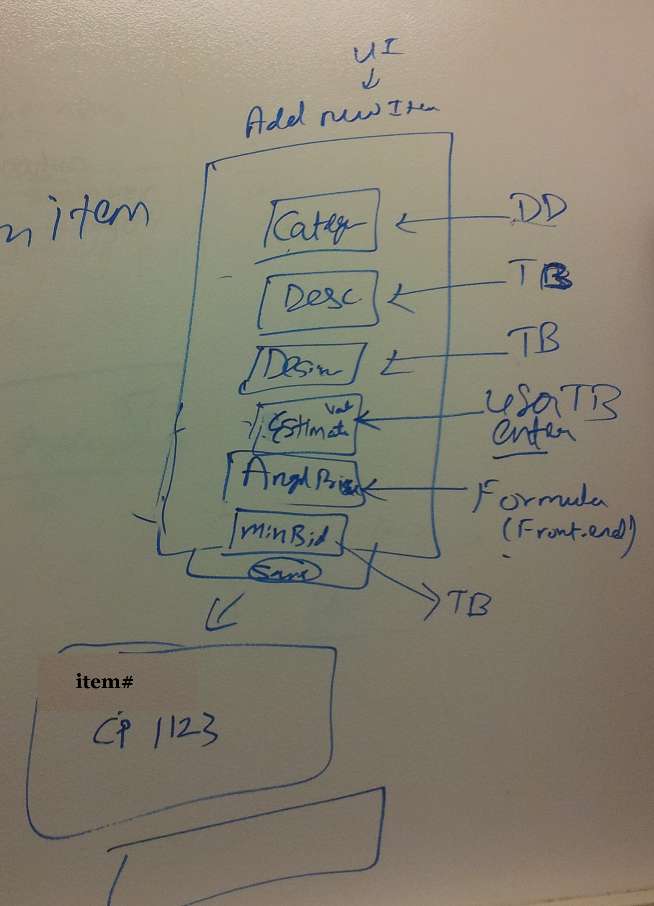

Angel price will be determined based on the formula (as mentioned in the req. document). After successful insertion of item information in the table, category# will be auto generated with pre-fix.(refer excel sheet)

1. Search/Edit Item-***Shubhanjli***

All the items need to be searched and updated from the below table: (Nikunj has created this table in the it485nnrs database, so **NO** need to create it again) (verify in your database once).

|  |
| --- |
| auctionitemstable |
| itemType: varchar(5)  itemNumber: Int Identity (Auto increment)  category: varchar(50)  itemDesc: varchar(200)  designer: varchar(50)  estimatedValue: varchar(50)  minBid: varchar(50)  angelPrice: varchar(50)  itemImagePath varchar(200)  PK on (itemType, itemNumber) |

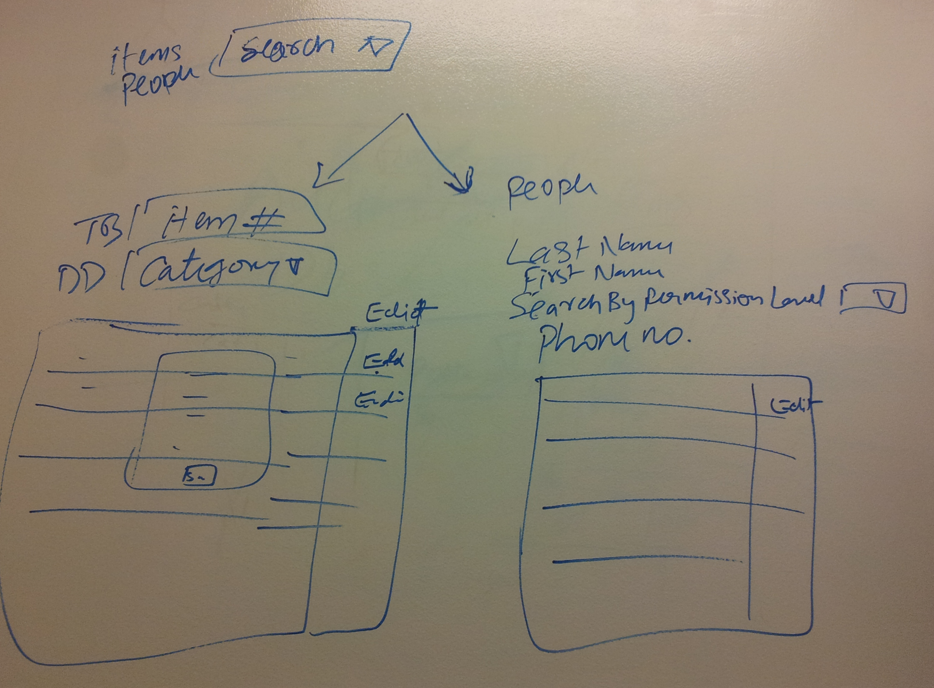

User should have an ability to search people and items both.

Search results should be displayed in form of grid (bootstrap) with edit button in the last column. If user clicks on edit button, an editable modal window (or similar) should appear with pre-populated values and save/cancel button. If user clicks on Save, the data should get updated in the DB and updated grid should be displayed (try with Ajax).

1. Email invoices/receipts (to successful bidders)-***Nivedita***

For now create a temp table as mentioned below & fill with the dummy data and later we will merge your code with the actual tables.

|  |
| --- |
| tempBidder |
| bidId: varchar(50) PK  email: varchar(50) FK  itemNumber: varchar(50) FK  winningStatus: varchar(3) –Should contain yes or no |

Fill some dummy value of email and itemId (make sure these 2 values i.e. value of email (signuptable) and value of itemNumber (auctionitemstable) are present. And while making sure bidId is PK pre-fill value for this as well.

Now, based on the email address and itemNumber fetch data (from signuptable & auctionitemstable) to fill the UI of email (mentioned below) (Note: winningStatus = ‘Yes’ must be consider in the where clause):

Try to mimic the invoice form provided on the project description site.

In the UI include below details:

* bidId
* email
* itemNumber
* First Name
* Last Name
* Bid Value (amount to be paid)
* Phone

For now, create a textbox to allow user to enter email and a button to send email. Make sure to include carousal in the email.

1. Export to Excel-***Rajneesh***

Use the assignment search feature and add a functionality to export the result to Excel sheet.

1. Forget Password-***Rajneesh***-**Modal window** <https://www.youtube.com/watch?v=mUoTwF9VxIM>

Make use of **signintable** present in our DB for this functionality. You can make enhancements in the login (aspx) page which is already created by Nivedita.

If user clicks on Forget Password link, a modal window should appear to allow user to enter email address. If entered email address does not have account in **signuptable** then through ajax call print a msg that please create an account. If account is existing in the **signuptable** then send email with username and password to the registered user.

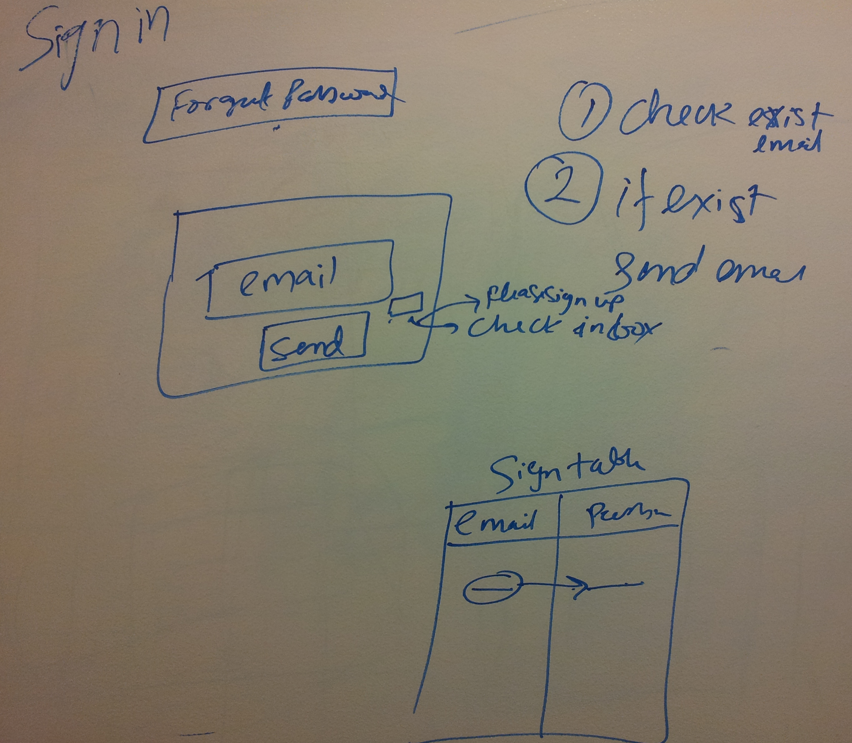

**\*\*\*\*\*\*\*\*\*\*\*Second Integration on Saturday 31 Oct 2015.\*\*\*\*\*\*\*\*\*\*\*\*\*\*\***

**Last Set of Modules (11/1/2015)**

1. **Check Bid Status: Nivedita (Discuss and add If I have missed anything!)**
2. You need to make changes in the email code -which winners will receive. Group all the “won” items by the user and put those item in the email receipt with the paymentStatus (which will be a new column in the TempBidder table) and total amount required to pay. For now, create 3-4 dummy rows with won status and paid/not paid status so that we can test it.
3. **User** should have an ability to enter his email (enter his email-for now, later we will fetch email from session level). Once user enter email and hit submit button (store email at session level), all the details of items on which user might have bided must be fetched in the table (Shubhanjli should be able to provide you a code to generate bootstrap table).

Since, our bidding deadline is not reached yet, all the winning status should show –**“*Under Process*” (Other 2 status are *Won* & *Lost*).** Once deadline crosses, Admin (or Steering committee member) will make changes in the status (by manually evaluating the winner and updating the winning status - Shubhanjli’s use case will take care of it) and those changes should be reflected in the later retrievals from DB. So, for now, below are the changes:

* Add one column in the table TempBidder – winningStatus Varchar(50)
* Make BidId AutoIncrement by 1
* Add one column PaymentStatus
* Don’t make phone number mandatory in DB(Nikunj will make it mandatory on UI while creating a bid sheet form)

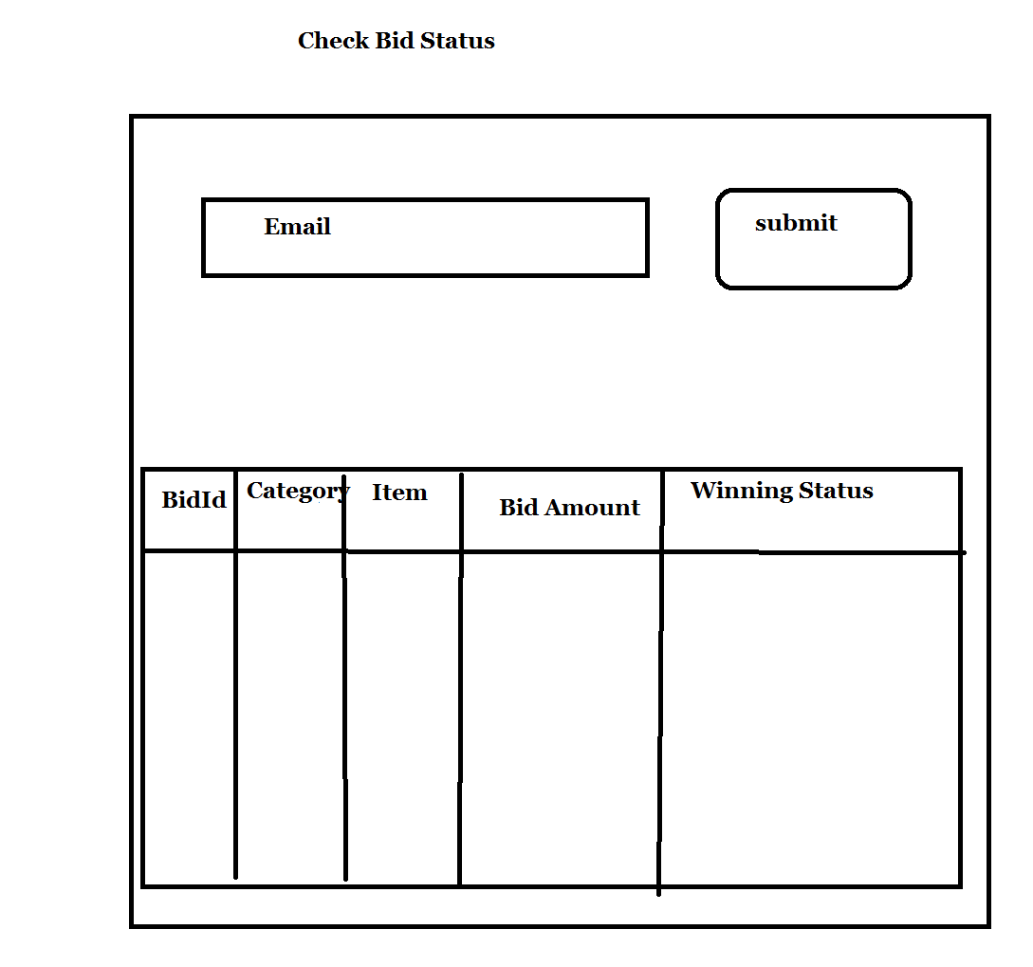

1. Display all items for auction, Bid Sheet-**Nikunj**

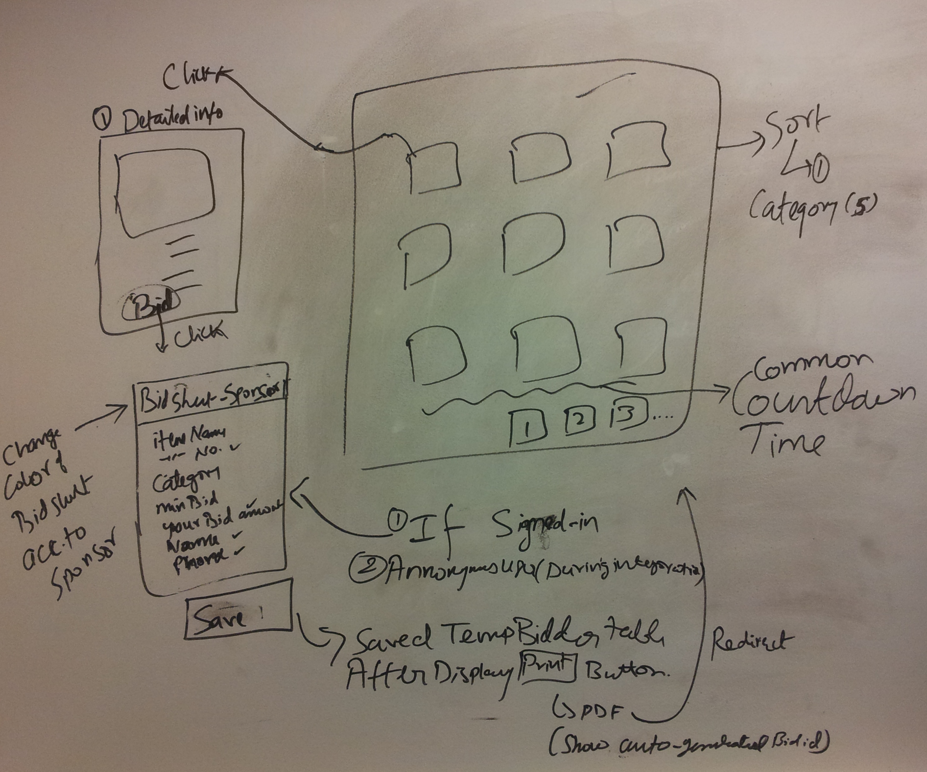

1. **Shubhanjli: (Ask me if you have any question)**
2. Web Service **client** to send text message. We will need to consume a web service for this.
3. **Admin** should have an ability to search **all** the people who were involved in bidding (that means **all** the bidders)- For this you need to get data from TempBidder table.

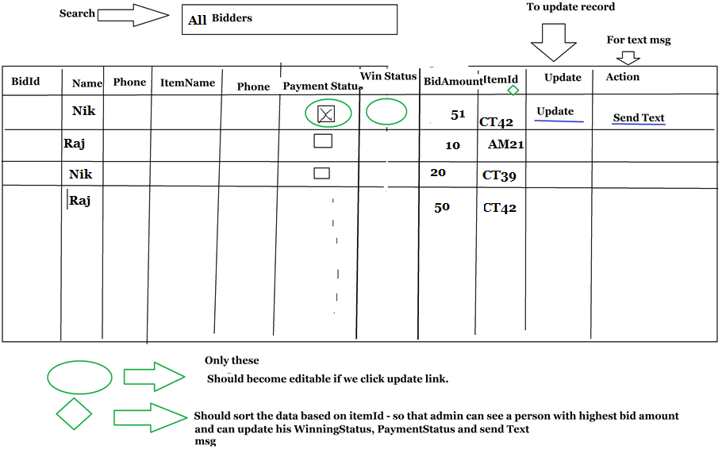

********************We will meet on 11/13/2015*********************